Testing between ChatGpt, Qwen, API (Qwen-turbo)
Question - what's the permit policy when we build a sun-room in Potomac, US?

Reply from API (temp = 0.7, token limit = 300)
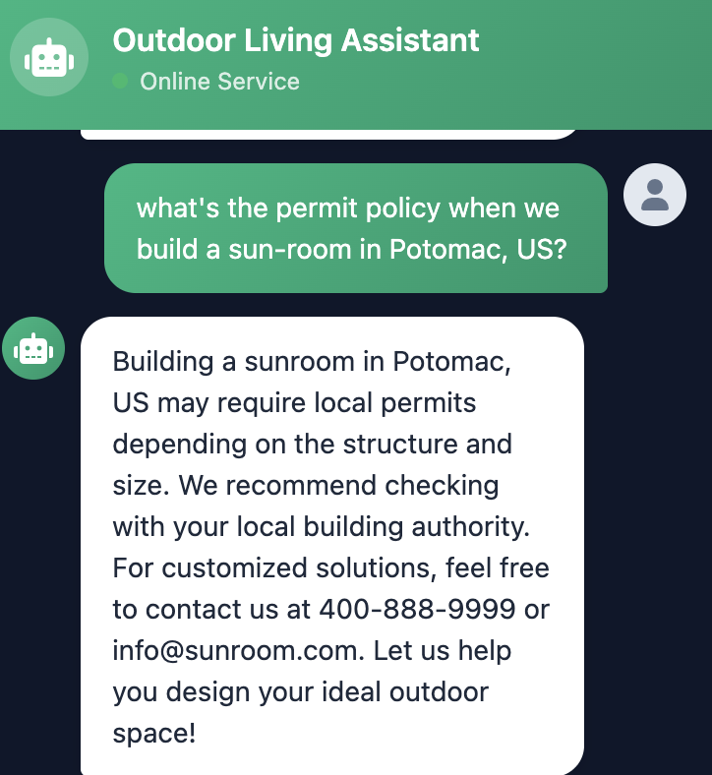

Reply from API (temp = 0.7, token limit = 500)
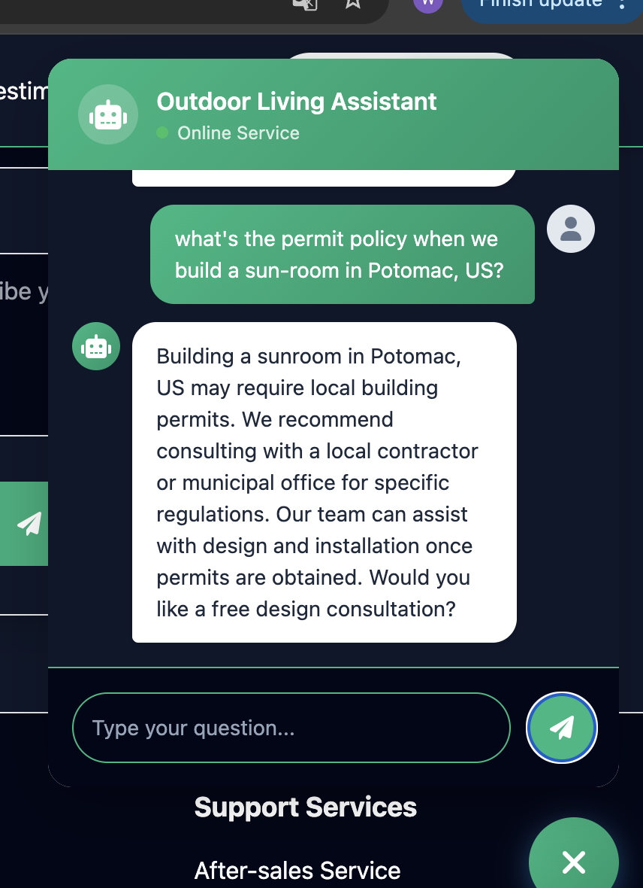

Reply by Qwen, generated after about 1.5 min thinking:-)

⚠️ Critical Clarification First
This answer assumes you refer to Potomac, Maryland (a census-designated place in Montgomery County). If you mean Potomac, Montana or another location, contact that specific jurisdiction’s building department immediately.
📍 Potomac, MD has no independent government—all permits are governed by Montgomery County, Maryland.

📜 Permit Policy Summary for Sunroom Construction
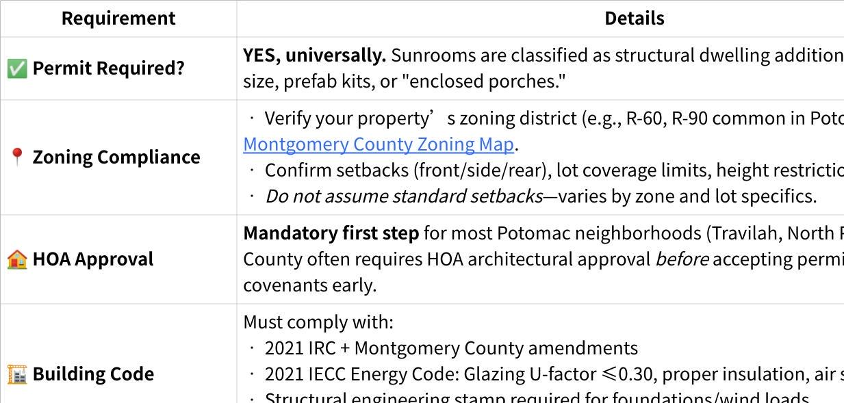
Click the image to view the sheet.

🔁 Typical Process
- Pre-Application:
- Contact HOA for design approval.
- Schedule free pre-application meeting with DPS: DPS Appointments.
- Submit:
- Apply online via ePermit Montgomery with stamped plans, site survey, energy docs, HOA letter.
- Review & Fees:
- Multi-department review (2–8 weeks). Fees ≈ $300–$1,000+ (based on project valuation).
- Inspections: Foundation, framing, final.
- Certificate of Occupancy: Required before use.

⚠️ Critical Pitfalls
- ❌ Skipping HOA approval → County application rejected.
- ❌ Assuming "small sunroom = no permit" → Violation risks fines, forced removal, resale issues.
- ❌ Ignoring energy code → Glass-heavy designs frequently fail without low-e glazing/insulation specs.
- ❌ Self-installing structural work → Montgomery County requires licensed contractors for framing, electrical, plumbing.

💡 Action Plan
- Confirm jurisdiction: Use Montgomery County Property Lookup with your address.
- Contact DPS directly:
📞 (240) 777-0311 | dps@montgomerycountymd.gov
🌐 DPS Sunroom/Room Addition Guide
- Hire locally experienced professionals: Architects/contractors familiar with Montgomery County reviews drastically reduce delays.
- Document everything: Keep HOA approvals, permit copies, inspection records for future resale.
📌 Disclaimer: Regulations change. This is informational guidance only. Always obtain written confirmation from Montgomery County DPS before design, purchase, or construction. Non-compliance may result in penalties, demolition orders, or title complications. When in doubt—ask the county first! 😊

Reply by ChatGpt. Generated almost instantly (don't know why).
Here’s a clear summary of permit requirements for building a sunroom in Potomac, Maryland (United States). Note: Potomac is unincorporated Montgomery County, so county rules apply.

🏡 1. Building Permit Required
Yes — in Montgomery County, MD, you must obtain a building permit before constructing a sunroom/solarium/room addition.
A sunroom is typically classified as a room addition or alteration to the existing structure, and is NOT exempt from permitting.

📜 2. Which Permits Are Typically Needed
You will generally need:
✔ Building Permit
Required for:
- Structural construction
- Footers, foundation work
- Framing
- Walls, floor, roof extensions
✔ Electrical Permit
If:
- You install lighting, outlets, ceiling fans, wiring
✔ Mechanical Permit
If:
- You install HVAC equipment, vents, ductwork
✔ Plumbing Permit
Rare for a sunroom unless:
- You add a sink, bathroom, or wet-bar
✔ Energy Compliance Documents
Sunrooms must meet energy efficiency standards under the Maryland Energy Code (insulation, glazing, thermal performance).

🧱 3. Code & Standards That Apply
Your project must comply with:
✅ 2018/2021 International Residential Code (IRC) – structure
✅ Maryland Building Performance Standards
✅ Montgomery County amendments
✅ Energy Code (insulation, fenestration U-factor requirements)

📐 4. Site Plans & Drawings
When applying, you must submit:
✔ Scaled site plan (showing property lines & setbacks)
✔ Construction plans (floor, elevations, roof)
✔ Foundation/structural details
✔ HVAC / electrical layouts (if applicable)
✔ Energy compliance forms

🚧 5. Setback & Zoning Rules
Sunrooms must obey:
🏠 Setbacks
Minimum distance from:
- Front property line
- Side & rear property lines
Exact distances depend on:
- Zoning district
- Lot size
Example: For many residential zones in Montgomery County:
- Rear setback ~ 25 ft
- Side setbacks ~ 8–10 ft
Check your specific zoning designation on county maps to confirm.

🧯 6. Historic or Environmental Overlay
If your home is:
✔ In a historic district
✔ In an environmentally sensitive area
you may need additional approvals (Historic Preservation Commission, environmental reviews).

🚪 7. Contractor Licensing
If you hire others to do the work:
✅ Contractors must be licensed & insured in Maryland
✅ Permits must list the licensed contractor
(Homeowner can pull the permit if owner-builder, but county requirements still apply)

🕐 8. Inspections
Once the permit is issued, you must pass a series of inspections at key stages:
📍 Footing/foundation
📍 Framing
📍 Electrical
📍 Mechanical
📍 Final inspection
Do not conceal work until inspections pass.

📇 9. Fees
Permit fees depend on:
- Project valuation
- Scope (electrical/mechanical/plumbing)
Montgomery County uses a valuation-based fee schedule.

📍 10. How to Apply
You can apply by:
🖥 Online
Through Permits & Licensing System:
https://aca.accela.com/montgomerycounty
📞 In-Person
Montgomery County permit offices
You’ll need:
✔ Property address
✔ Tax ID (MC#)
✔ Contractor info
✔ Construction drawings

🧠 Quick Checklist
Before starting a sunroom project in Potomac:
✅ Check zoning & setbacks
✅ Draft architectural & structural plans
✅ Submit permit applications
✅ Address energy compliance
✅ Schedule inspections

📌 Important Notes
🔹 Even small additions like sunrooms require compliance — don’t assume “no permit”.
🔹 Unpermitted work can lead to fines and forced removal.
🔹 Always consult the Montgomery County Code Enforcement Division if unsure.

If you want, I can also prepare:
📌 A step-by-step permit application checklist,
📌 A summary of costs/fees for similar projects,
📌 Or a sample set of required document templates.
Just let me know!

Take-away from the testing
- The answer from both ChatGPT and Qwen looks good, but will be quite token consuming.
- The token limit (300 vs 500) does not tell big difference. Shall we push up the limit, which will stand for the cost rising?
- Is that due to the temperature setting?

